CENTRAL VIGILANCE COMMISSION (CVC), NEW DELHI
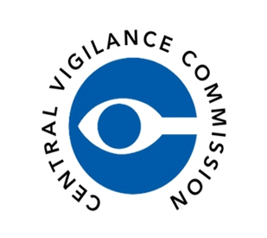
ALL INDIA COUNCIL FOR TECHNICAL EDUCATION, NEW DELHI
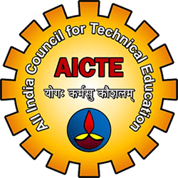
KALINGA UNIVERSITY, RAIPUR (C.G.)
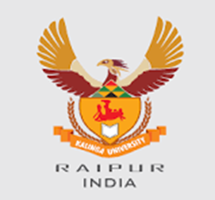
FACULTY OF TECHNOLOGY
Theme: “सतर्कता: हमारी साझा जिम्मेदारी”
“Vigilance: Our Shared Responsibility – Education for Integrity and Transparency”

DAY 4 – Colours of Honesty – Poster & Slogan Exhibition
Date: 30 October 2025 | Time: 10:00 AM – 11:30 AM
Venue: WBFF 02 (Hybrid Mode)
Organized by: Faculty of Technology & Faculty of Education, Kalinga University, Raipur (C.G.)
Under the Guidance of All India Council for Technical Education (AICTE) and Central Vigilance Commission (CVC India)
The Faculty of Technology and Faculty of Education jointly organized a creative event titled “Colours of Honesty – Poster & Slogan Exhibition” as part of Vigilance Awareness Week 2025. The exhibition was inaugurated by Prof. Dr. Shraddha Verma, Dean, Faculty of Education, who addressed the students on the significance of ethical awareness through visual communication. Students from both faculties expressed their understanding of integrity and vigilance through thought-provoking posters and slogans.
The artworks highlighted values of honesty, transparency, and anti-corruption, creatively connecting them to daily life and education. Selected entries were showcased in the department corridor and featured on Kalinga University’s digital platforms as part of the “Integrity Week Showcase.” The event fostered value-based learning and inter-faculty collaboration in promoting ethical responsibility.
Theme: “सतर्कता: हमारी साझा जिम्मेदारी”
“Vigilance: Our Shared Responsibility – Education for Integrity and Transparency”

Official Links:
• Central Vigilance Commission (CVC): https://www.cvc.gov.in
• All India Council for Technical Education (AICTE): https://www.aicte.gov.in
• Kalinga University: https://www.kalingauniversity.ac.in

#VigilanceAwarenessWeek2025 #IntegrityFirst #CVCIndia #AICTE #KalingaUniversity #EthicsInEducation #TransparencyMatters #SatarkBharat #OurSharedResponsibility

